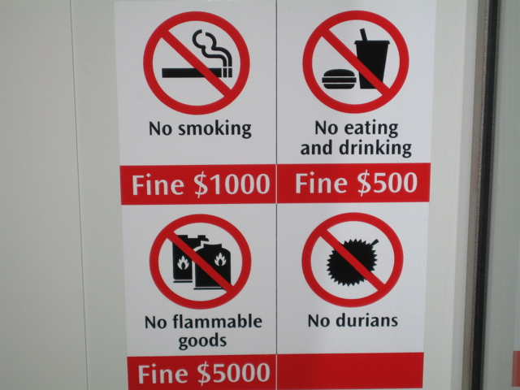  Apps to Help Navigate Singapore:  CityMapper  MyTransport.SG  Grab  GoThere.SG  SG Buses  LocoMole | Welcome to MWR  Singapore  Morale, Welfare & Recreation Singapore is located just north of the equator on the sunny, tropical island city-state of Singapore.  Our dedicated mission is providing a quality of life for our military and their families through fitness & sports, child & youth programs, food & beverage services, and a wide availability of recreational activities.  MWR is always looking for feedback on the services they provide. Please take a few minutes to complete a survey by clicking on the appropriate program below and let us know how we’re doing. Any input, positive or negative, is welcome.  Please visit our online survey by SurveyMonkey:  https://www.surveymonkey.com/r/CommunityRecSingapore  MWR COMMUNITY RECREATION  cro.mwrsg@gmail.com | MWR COMMUNITY RECREATION  - Navigating the MRT in Singapore
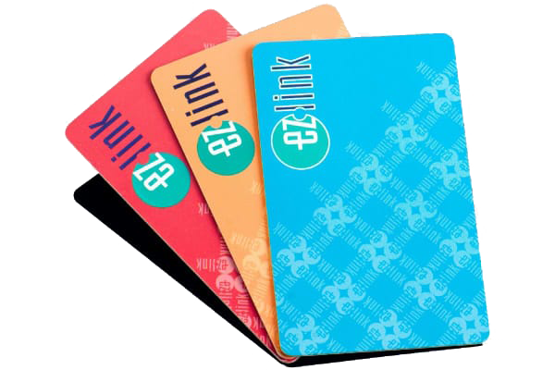  How to get an MRT Pass  From Terror Club: Bus stop 58191 (Aft Wellington Rd) Fare is $0.93 SGD to Yishun MRT station. Ride 9 stops to Opposite Yishun Station.  Once inside the station go to TransitLink Ticket Office, open from 0800-2200 to purchase EZ-link card, for more information visit www.ezlink.com.sg  A card will cost you $12 SGD ($5 for the card with $7 stored credit) you may add more value to the card at the ticket office or at the available credit machines at every station. | MRT to Sentosa (travel example)  From Terror Club: Bus stop 58191 (Aft Wellington Rd)  Ride 9 stops to Opp Yishun Station and walk across under the underpass through to opposite side of station. (Follow signs to MRT)  Wait for NS (MRT North South Line) towards Marina South Pier. Ride 11 Stops to Dhoby Ghaut station.  Change platform to NE (MRT North East line) towards Harbour Front. Ride 4 stops to Harbour Front.  Change platform to Sentosa Beach (light rail).  Choose from any station based on attraction you are going to.  *Always keep a minimum balance of at least $3 every day* | 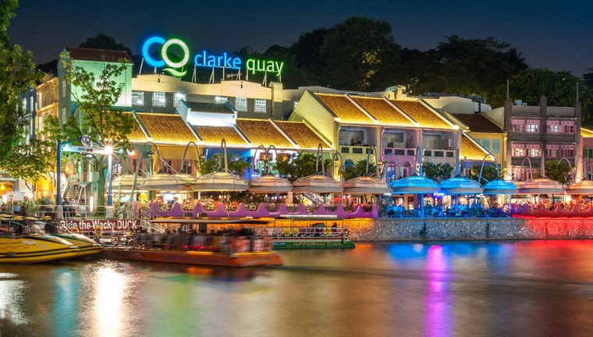  MRT to Clarke Quay (travel example)  From Terror Club: Bus stop 58191 (Aft Wellington Rd)  Ride 9 stops to Opp Yishun Station and walk across under the underpass through to opposite side of station.  Wait for NS (MRT North South Line) towards Marina South Pier. Ride 11 Stops to Dhoby Ghaut station.  Change platform to NE (MRT North East line) towards Harbour Front. Ride 1 stop to Clarke Quay.  Walk to venue of your choice.

