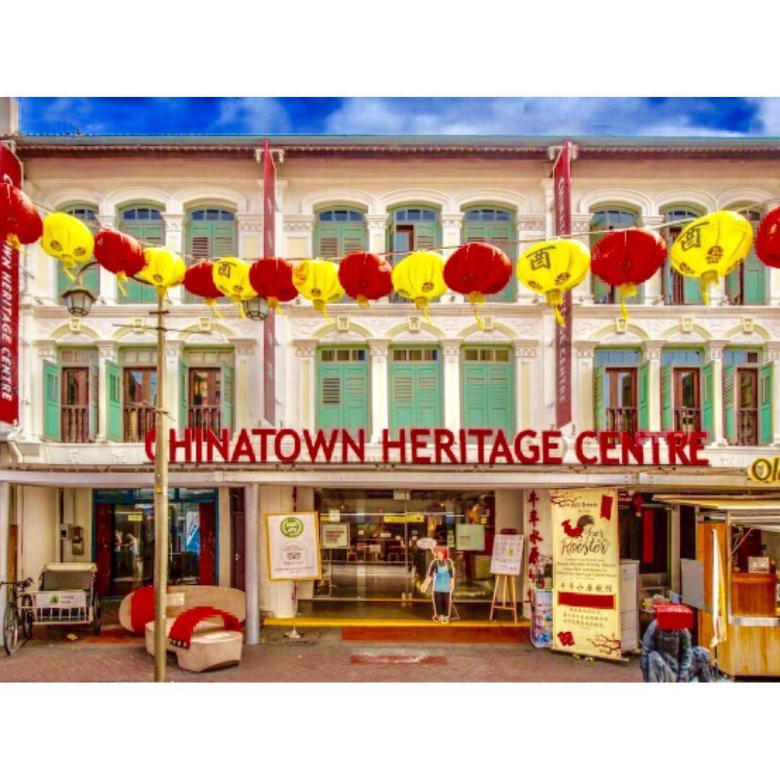  Chinatown Heritage Center  48 Pagoda Street, Singapore 059207  Located within three beautifully-restored shop houses on Pagoda Street, the Chinatown Heritage Centre is a time capsule that holds stories of Singapore’s past.  Dedicated to documenting and recreating the lives of Chinatown’s earliest residents, the space comprises six galleries, conserved living spaces and a range of immersive experiences. | Welcome to MWR  Singapore  Morale, Welfare & Recreation Singapore is located just north of the equator on the sunny, tropical island city-state of Singapore.  Our dedicated mission is providing a quality of life for our military and their families through fitness & sports, child & youth programs, food & beverage services, and a wide availability of recreational activities.  MWR is always looking for feedback on the services they provide. Please take a few minutes to complete a survey by clicking on the appropriate program below and let us know how we’re doing. Any input, positive or negative, is welcome.  Please visit our online survey by SurveyMonkey:  https://www.surveymonkey.com/r/CommunityRecSingapore  MWR Community Recreation  cro.mwrsg@gmail.com | MWR Community Recreation  - Cultural Tours of Singapore
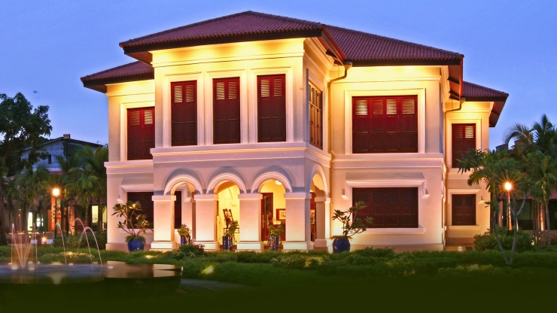  Malay Heritage Center  85 Sultan Gate, Singapore 198501  Built 160 years ago by Sultan Ali, the son of Sultan Hussein Shah, Istana Kampong Glam was once the royal seat of the Malay sultans in Singapore.  Beautifully restored to its former glory, the Malay Heritage Centre sits within these well-preserved grounds and is a must-visit for anyone interested in understanding the history of Singapore’s Malay community. | What is Heritage?  Singapore’s heritage is found all around us and experienced as we go about our daily lives. From stately historical buildings and precious museum artefacts to festive celebrations and food offerings, Singapore’s rich and diverse multicultural heritage is one of the defining traits of our country, and of our identity as Singaporeans.  Heritage can be broadly categorized into tangible and intangible cultural heritage.  Tangible heritage includes buildings, historic sites, monuments and landscapes that serve as physical reminders of our history and culture. It also includes objects that institutions and people create and/or collect. These objects, which form an important part of a nation’s history and cultural identity, include artefacts, artworks, documentary records, photographs, films and other objects of significant historical value. | 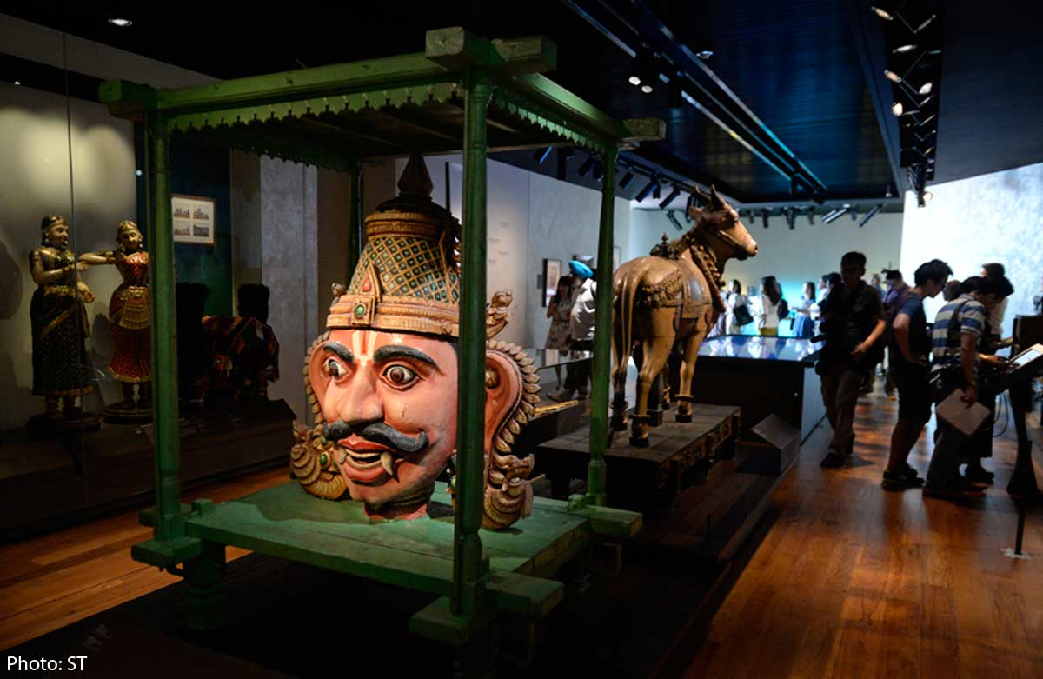  Indian Heritage Center  5 Campbell Lane, Singapore 209924  Tel: (+65) 6291 1601  www.indianheritage.org.sg  The four-story building is an iconic, unique and sustainable building that blends both traditional Indian as well as modern architectural elements. The architectural design for the facade is inspired by the baoli (or Indian stepwell), and seeks to create an urban forum for the celebration and appreciation of Indian culture. It houses five permanent galleries, a museum shop as well as programming and activity spaces.

